**Unit 1**

**RESEARCH PROBLEM FORMULATION**

**Research**

Research is a process of systematic inquiry that entails collections of data.

It is called as documentation of critical Information.

Analysis and interpretation of that information or data with suitable methodologies.

“A careful investigation or inquiry especially by searching for new facts in any branch of knowledge”.

**Objectives of Research**

To have a better understanding of an existing problem.

To gain familiarity with a phenomenon or to achieve new insights.

To investigate a problem that has not been studied or thoroughly investigated in the past.

To test a hypothesis of a casual relationship between variables.

To solve a problem or addressing specific challenges.

It aims to provide reasonable solutions.

**Types of Research**

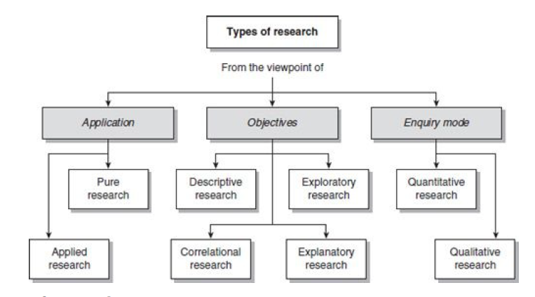

**Applied Research**

Applied research focuses on analysing and solving social problems

Finding a solution for immediate problem facing by a society or business organizations.

Its findings are used to develop new technologies and products.

While pure research discovers principles and laws, applied research discovers ways of applying them to solve social problems.

**Eg**. Agricultural Research: Developing more efficient and sustainable farming techniques to increase crop yields and reduce environmental impact is an example of applied research. This research aims to address practical challenges in agriculture

**Pure Research (Fundamental)**

It is pure mathematics.

It concerns the principle or laws or fundamental rules and it aims of achieving knowledge.

It is mainly focuses on verifying and removing doubts.

If the doubt proves correct, you can modify the concerned principles and laws according to the conclusion and results of pure research.

**Objective Research**

**Descriptive**

Descriptive study attempts to describe systematically a situation, phenomenon information about living conditions of a community or describe attitude towards an issue.

Provides detailed and accurate description of an event.

Eg. How a child fees living in a house with domestic violence.

**Exploratory**

This is a case when a study is undertaken with the aim of exploring an area about where little is known.

When it is used to determine feasibility it is called as feasibility study.

It is data-based research, coming up with conclusions which are capable of being verified by further observation or experiment

**Correlational**

The main emphasis in a **correlational study** is to discover or establish the existence of a

relationship between two or more aspects of a situation.

For eg,

What is the impact of an advertising campaign on the sale of a product?

What is the relationship between stressful living and the incidence of heart attack?

What is the relationship between fertility and mortality?

What is the relationship between technology and unemployment?

What is the effect of a health service on the control of a disease, or the home environment on educational achievement?

These studies examine whether there is a relationship between two or more aspects of a situation or phenomenon and, therefore, are called correlational studies.

**Explanatory Research**

**Explanatory research** attempts to clarify why and how there is a relationship between two aspects of a situation or phenomenon.

This type of research attempts to explain, for example, why stressful living results in heart attacks;

Why a decline in mortality is followed by a fertility decline;

How the home environment affects children’s level of academic achievement.

**Enquiry Mode**

**Quantitative Research**

Quantitative research is based on the measurement of quantity or amount.

It is applicable to phenomena that can be expressed in terms of Quantity. Quantitative research often addresses questions that can be answered with numerical data. It focuses on "how much," "how many," and "to what extent" questions.

It is also called as Structured approach.

**Qualitative Research**

Qualitative research presents a non-quantitative analysis or is concerned with a qualitative phenomena, that is a phenomenon relating to or involving quality or kind.

Investigating the reasons for human behavior (i.e., why people think or do certain things), - ‘Motivation Research’.

Qualitative research is especially important in the behavioral sciences where the aim is to discover the underlying motives of human behavior.

It is also called as Unstructured Approach.

**Some other types of research,**

Conceptual

* + related to some abstract idea(s) or theory
  + used by philosophers and thinkers to develop new concepts or to reinterpret existing ones

Empirical

* + relies on experience or observation alone, often without due regard for system and theory
  + data-based research
  + experimental type of research

**Research Process**

Phase I: deciding what to research

Step I: formulating a research problem

Phase II: planning a research study

Step II: conceptualizing a research design

Step III: constructing an instrument for data collection(observation,interview,questionaire)

Step IV: selecting a sample

Step V: writing a research proposal

Phase III: conducting a research study

Step VI: collecting data

Step VII: processing and displaying data

Step VIII: writing a research report

**Components of a Research problem (Not in Syllabus)**

* There must be an individual or a group which has some difficulty or the problem.
* There must be some objective to be attained at. If one wants nothing, one cannot have a problem.
* There must be alternative means (or the courses of action) for obtaining the objective one wishes to attain. This means that there must be *at least two means available to a* researcher for if he has no choice of means, he cannot have a problem.
* There must remain some doubt in the mind of a researcher with regard to the selection of alternatives.
  + This means that research must answer the question concerning the relative efficiency of the possible alternatives.

There must be some environment(s) to which the difficulty pertains

**Purposes of Literature Review**

* A literature review is part of a report.
* It provides considerable information on the topic being researched and the various works that had gone on in the field over the years.
* These materials are gathered by the researcher from many sources such as journals, books, documents etc.
* It can be just a simple summary of the sources, but it usually has an organizational pattern and combines both summary and synthesis
* It might give a new interpretation of old material or combine new with old interpretations.
* In summary all the information is synthesized and given in a capsule form.

**Difference between Literature review and Academic research report**

* The main focus of an academic research paper is to develop a new argument , a research report will contain the literature review as one of its chapters.
* In a research report one uses the literature as a basic foundation and support for newer ideas and insights into the research topic of interest.
* Literature review on the other hand summarizes and synthesizes the many arguments and literature and research findings gathered from such a review and puts forward arguments in favour or against the particular topic and its findings.

**Materials to be included in review of Literature**

* + The researcher has to definitely include the materials from classic and pioneering works in the area.
  + In addition the researcher should also include all the relevant research works published more recently especially in the last 5 to 10 years.
  + This includes books, journal articles, monographs, documents, grey literature such as unpublished documents or research papers read at some conferences etc.
  + In addition the internet is an important source from where articles and abstracts could be downloaded for this purpose.

**Special purpose of review of literature**

* Identifying variables relevant for research
* Avoidance of repetition
* Synthesis of prior works
* Determining meaning and relationship among variables

**Sources of the Review of Literature**

* Journals and Books
* Reviews
* Abstracts
* Indexes
* Internet
* Doctoral Dissertations
* Supervisors/ Research professors

**Click here for brief explanation**( Page no. 21)

**Types of Review of Literature**

* + Subject-Specific Books
  + Grey Literature
  + Official Publications, Archives and Statistics
  + Writing Aids
  + Journal Articles

**Information Retrieval**

The efficiency of information services from a database is directly related to its

capability of retrieval of information.

Information retrieval plays a vital role in the research methodology of any study, as it involves the systematic collection of data, information, and literature that are relevant to the research question or objectives.

It refers to the process of systematically searching for, identifying, and obtaining relevant information and data for your research project.

An Information Retrieval System (IRS)

* Capable of storage, retrieval and maintenance of information.
* A software system that facilitates the user in finding required information.
* Efficiency of information services depends largely on the retrieval efficiency of the databases

Due to some challenges of retrieval of information in repositories, it is necessary to create pointers or keys to actual information in collection.

Indexing is a process of enlisting important terminology and storing them along with location information for each information.

When a user approaches the system with a query the system can look up the list of terminology and display the term that match the query terms along with its location.

Tools for literature review

First, an overview of the literature search tools in this blog post:

* ScienceOpen
* The Lens
* Citation Gecko
* Local Citation Network
* ResearchRabbit
* Open Access Button
* Unpaywall
* EndNote Click
* Read by QxMD
* CiteAs

**Indexing and Abstracting**

* Indexing and abstracting periodicals are called secondary publications.
* They are the access tools to already published primary documents such as, articles/papers in newspapers and periodicals, research papers, reports, patents, conference proceedings and so on.

It is organized in a convenient manner to search the location of entries.

An Index can be alphabetical, classified, chronological, geographical or numerical.

They are access tools to identify and locate the required information which appeared in a particular periodical,

**Indexing periodicals** provide lists of articles with bibliographical details arranged in

user-friendly order to enable a user to trace the needed information easily and quickly

**Abstracting periodicals** not only list the bibliographical details but also provide abstracts of documents in a specific field or a group of subject fields helping the reader for his choice of an article or a paper.